Joel 2 Missions
Bringing in the Harvest
Joel 2:25-26

“So, I will restore to you the years that the swarming locust has eaten…. You shall eat in plenty and be satisfied and praise the name of the Lord your God.”
Joel 2:25-26
Dear Family, Friends, and Partners,
Beloveds, I have seen God do something that I never dreamed would be possible! Because of this miracle, I am coming to you in a newness of faith and perseverance, convinced of the glory of God that will be revealed in and through His people in this hour! If you have not yet heard, the Lord made the way for me to fly to Louisiana, meet face-to-face with my father and forgive him. What was even more miraculous is that I was blessed to preach the gospel to him and lead him to faith in Christ! The Lord has shown me that this is the year of beholding His glory and I believe like never before that I have heard Him! Please take time to follow this link to hear more about what I believe God is saying for such a time as this.

As far as the building is concerned, we are almost there!!! Check out the update below!

This newsletter will be a little different in format because we have so much information to share with you. Please, if you have not already done so, like us on FB at www.facebook.com/Joel2Missions for up-to-date information on events and more.

In His Service,

Paula Millsaps
Founding Director
Joel 2 Missions
(910) 599-0991—NC

WHAT WE HAVE BEEN UP TO DURING THE THIRD QUARTER OF 2021:
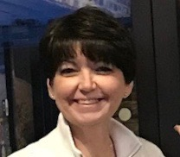
We welcomed Kristy Over to our board as our new Fundraising Chair!!!

​​Originally from the Uniontown area, Kristy has lived in numerous areas and travelled extensively related to my husband, Gary’s, Naval career. After his retirement, the Overs moved back to Fayette County to take care of Kristy’s ailing parents. They are currently members of Asbury United Methodist Church in Uniontown. During her employment career, Kristy had the opportunity to work in several fields: mainly healthcare and nonprofit. She has worked for healthcare providers, health insurance companies as well as benefit management companies. She worked for a large Defense Contractor and was Executive Administrator for a children’s agency outside of Washington, DC and works as a free-lance grant writer in her spare time. She is currently Director, Client Management for an international health care company. The Overs currently live in Uniontown with their new, baby puppy Luna. They have two children and five grandchildren. Their son, Gary, is a Lt. Colonel in the US Air Force. He is currently stationed at Fallon, NV/TOPGUN wth his wife, Danielle and his 3 children, Gary, Adriana and Emma. Their daughter Melissa is a registered nurse who is finishing up her schooling to be a Nurse Practitioner. She lives in Uniontown with her husband, Tom and their twin daughters, Isabella, and Alexandra.

Kristy has already submitted grant applications to two private foundations for funds to replace our roof! Please be in prayer that we receive these funds as this is a much needed provision.

The Beholding Prayer Initiative—Ten Days of Awe

What an amazing time in the Lord we had at the Beholding Gathering! The Presence of God was tangible! Melissa Sylvis blessed us with anointed worship and guests came from all over the region to minister unto the Lord! This Gathering concluded ten days of fasting and prayer to mark and honor the Ten Days of Awe including Rosh Hashanah and Yom Kippur. Our focus for this prayer time was simply to seek the face of God and was robust with testimonies of how God showed up during prayer times in miraculous and impactful ways. While we regretted having to reschedule the Unveiling Conference and Retreat, we know that God has His way and did what He wanted with that time. We are thankful to all who attended and worshipped with us.

J2M Volunteer Workdays

God is so faithful! All your hard work on the workdays has paid off so richly! There is still much to do, but there has been so much improvement. Take a look at what 120 tons of gravel does for the outside of a building! Also, please give honor to God for the faithful volunteers who came out all summer.
WHAT GOD DID:
He brought volunteers from multiple churches including Asbury United Methodist, South Hills Calvary Chapel, New Wine Harvest, and Transformation Christian Center. These ladies represent two churches, Asbury UMC and Transformation Christian Center.
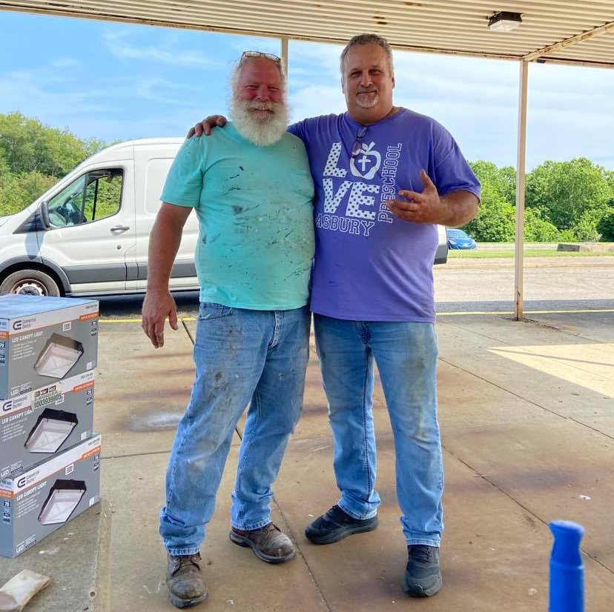
This is Dave from New Wine Harvest and Pastor Don from Asbury UMC.

And below is Susan and her son Rich spreading gravel and working on landscaping.
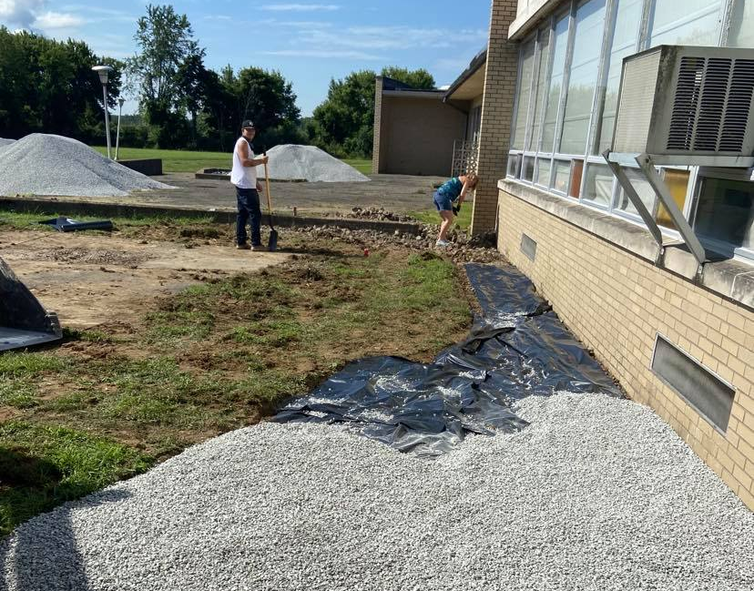

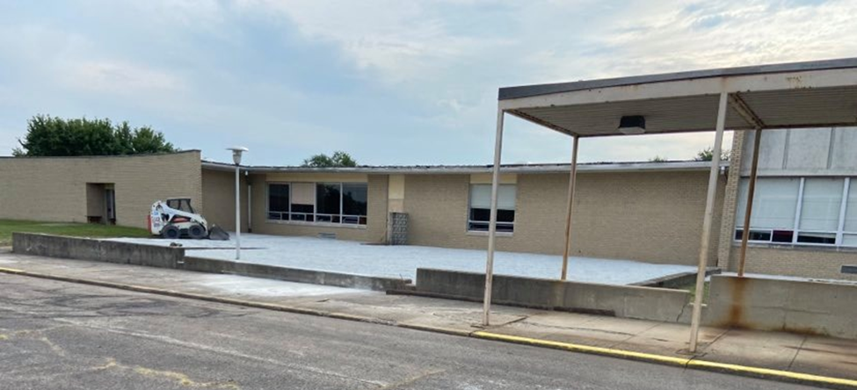

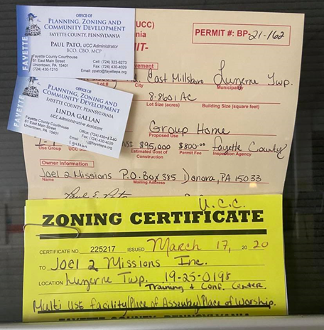
And we finally got our zoning certificate and building permits! God is on the move, and we are really excited with all He has done over the past few months! We are believing for continued momentum into the end of the year as we finish the renovations and prepare for residency. The sprinkler company has quoted us $30,000 for all materials! Gerry Marburger, our sprinkler engineer, has agreed to oversee and help us with installation. We just need volunteers willing to give up a lot of Saturdays this winter. Volunteers are also required to take a FREE installation course at THIS LINK. We are being endorsed by Brown Sprinkler Company in Dorset, OH. When registering for training, please enter that company name and then email us at joel2missions@gmail.com so that we can let the owner know that you are part of our team. Once this on-line course is completed, a certificate and card will be mailed to you. This is a certificate that can be used for job skills training in the search for gainful employment as well! PLEASE BRING BOTH WITH YOU ALONG WITH A VALID ID ON FIRST VOLUNTEER DAY. Mike Ardeno from Central Assembly of God has volunteered as Master Plumber to oversee the work. If you are interested in volunteering for the sprinkler project, call 910-599-0991.

UPCOMING EVENTS:

Joel 2 Missions Fall Fundraiser: Saturday, October 23, 2021, 5:00PM

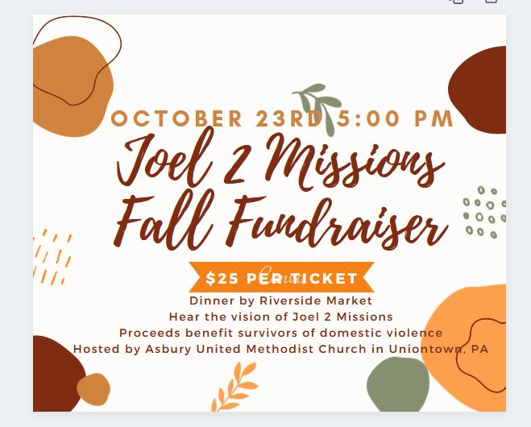

Our goal is to raise the $30,000 that we have been quoted for supplies needed to install our sprinkler system. This is our final push toward opening and we need YOUR help! Please share, invite, and buy tickets by clicking here. You can also give your end-of-year gifts by texting “GIVE” to (855) 338-1054 or mailing checks to Joel 2 Missions at PO Box 385, Donora, PA 15033.
Joel 2 Family Thanksgiving

We are excited to be gathering again this year for our Family Thanksgiving! On Friday, November 19 at 6:30 pm during our normal Gathering time, we will have thanksgiving dinner as a family. Please keep a look-out for the FB event to sign up for number of guests and dish to pass. As usual, Joel 2 will provide meat, water, and paper products. We will leave everything else up to you all! Please feel free to bring anyone who needs the love of family!

ONGOING EVENTS:

Counseling Sessions Available Every Wednesday with Sister Paula

If you would like counseling, mentoring, or just to chat with Sister Paula, she has “office” hours every Wednesday. Appointments are set up in one-hour blocks. Please contact Cathy at (910) 599-0991 to set an appointment. Please also specify what type of appointment you need and whether you prefer phone, zoom, or in-person meetings. Thank you.

Prayer Ministry

We have been seeing tremendous success during prayer ministries. These appointments are limited as we are booked up through late fall and always occur on Saturdays. There are still a few available and we can put you on a cancellation list. Call Cathy at (910) 599-0991 to schedule.

The Gathering at J2M

Please join us Friday evenings at 6:30 pm at 234 Arensburg Road, East Millsboro, PA 15433. The Lord has been showing up in such wonderful ways at these meetings. We do not feel led to livestream these meetings, but all are welcome to join us in person. The Gathering is a place where people can come together just seek His face. Worship is the focus and there is an open mic for members of the Body to share what the Lord is showing them either through the Scriptures or revelatory gifts. If you would like more information, please email us at joel2missions@gmail.com.

Regional Oneness Apostolic Roundtable- ROAR 2020 (June 2020- Now)

Born out of this time of deep intercession, reset, and refocusing, the Regional Oneness Apostolic Roundtable (ROAR 2020) is a group of Five-Fold Ministry Gifts gathered together from three states currently. The purpose is to provide a place for all parts of the Body of Christ to come together, hear from the Lord His plans and purposes for this region, and then seeking God together for the strategies for how to implement these plans in the earth. The response has been tremendous, and the Lord is already moving and uniting through this group. If you are interested in more information about ROAR, please email us at joel2missions@gmail.com.

To Give, visit: https://tithe.ly/give?c=1235990

Or send a Check or Money Order to: Joel 2 Missions, P.O. Box 385, Donora, PA 15033

You are appreciated and loved dearly! We pray a hundredfold return on all that you do in the mighty name of Jesus! Please send us your prayer requests so we can agree with you for the will of God to be done in every area.

**Joel 2 Missions, Inc is a 501©3 non-profit organization. All donations are tax deductible. Giving statements will be sent out no later than January 31, 2021**

