Joel 2 Missions
Bringing in the Harvest
Joel 2:25-26
“So, I will restore to you the years that the swarming locust has eaten…. You shall eat in plenty and be satisfied and praise the name of the Lord your God.”

Dear Family, Friends, and Partners,
Hello everyone! My what a wonderful time to be alive! God is on the move! It is not difficult to see that the world around us is engulfed in darkness, but I believe that just makes the light shine brighter! It is certainly the bright light of the Lord that we have been seeing shine on and through Joel 2 Missions in this season. It is my prayer that you are experiencing that same wonderful Light during this time. Many of you know that God has planted us in a town called Donora. This is a little town, a Borough really, here in the Monongahela River Valley of SW PA. The first time I came to this region Donora was one of the towns we drove through to get to the Witch Festival where we ministered to people and prayed. As we drove across the bridge into Donora, a run-down billboard met my eyes. On it was written, “Donora, Home of Champions.” I began to weep uncontrollably as I read those words and saw the abject poverty that this little town was obviously trapped in. Papa then asked me question, “what do you see daughter?” I replied, “I see death and depression, Lord.” Then He asked, “can these dry bones live?” My response was a resounding, “Oh yes, Lord! With You they certainly can!” In that moment God birthed a love in my heart for this region. Along with that love came the desire to see this little town restored to the place of glory God intended! I want to see Donora be once again “the Home of Champions” rather than the home of the poor and needy. It has been a slow-going process mainly involving the steady building of relationship with the people of this region, but when I returned from VOA this past week, a wonderful surprise awaited me. One of the young men we have been loving on is the largest drug dealer in this town. Recently he was given a copy of my book “This is My Story” which tells that whole account of my testimony and the darkness God brought me out of into His marvelous Light. Three days after reading it, he was arrested and is now in jail. When I came home from VOA, I had a letter from this young man waiting on me. His letter was simple. All he asked was, “Ms. Paula, can you tell me what the steps are for me to be saved? I really want to be saved and live for Jesus. I am tired of this life of drama and after seeing what He did for you, I believe He can do it for me.” Y’all, I am still undone!!! I replied to his letter an explained that he just has to believe with his heart and confess with his mouth that Jesus Christ is Lord and am planning to go visit him this week. This, I believe, is the beginning of the end for satan in this town! This young man will have a tremendous impact for the Lord here and in surrounding areas. This IS the home of champions, and this young man is the first fruits of seeing that truth manifested throughout this valley, in Jesus name! Please keep him and us in your prayers as we plunder hell and populate heaven for the glory of the Lord! Also, grab a hold of this testimony and know that NOTHING is too hard for our God! Maybe you have a lost loved one, a prodigal child, a friend who is trapped in darkness. There is HOPE for them! Just keep loving! Just keep praying! Just keep contending! Jesus will prevail as He has already overcome the world!!!

Let us know of any specific prayer requests you might have as we do pray over each of you and your families.

In His Service,

Paula Millsaps
Founding Director
Joel 2 Missions
(910) 599-0991

LOOK WHAT THE LORD HAS DONE!
A New Addition to Our Housing Program!

We have a new resident!!! Meet Sarah Horning! She is an amazing addition to our Joel 2 family and came to live with us in the staff house in August of this year. Sarah comes to us as a third term resident and we could not be happier to have her! Please keep her covered in prayer as she walks out healing and discipleship as we team up to help equip her for the call of God on her life as a missionary.

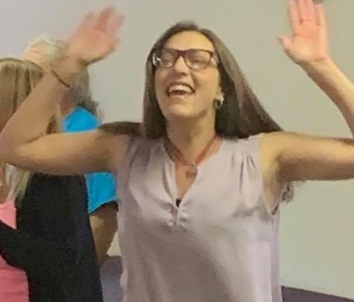
AGLOW International—Clearfield Chapter (August 28)

God showed up and did amazing things during this meeting! As Sister Paula shared her testimony, this young lady began being delivered from demonic oppression. During the prayer time, many were delivered, including a woman who had suffered from drug addiction for decades, and some received healing from the Lord. In all, about 30 women were healed or delivered at this meeting! To God be the glory! (Picture shared with permission)

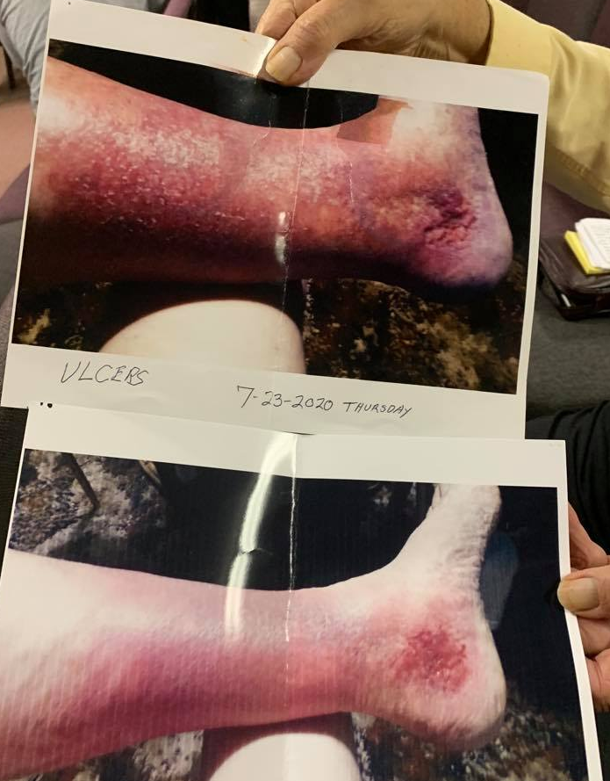
Jubilee Christian Center (August 28-29)

The Lord was so gracious to us during these meetings! Most notable was the physical healing of a precious man of God named Jay. He came up for prayer for his legs which were ravaged by ulcerative sores from lack of blood flow to his lower extremities. Sister Paula laid hands on the sores and asked God to heal them by morning. The next morning Jay came in and all the sores were healed! (The first picture was from July—when he came for prayer the sores were actually worse as they were open and seeping—the second picture is from the morning he woke up healed!) There was also more deliverance and inner healing that came as Holy Spirit blew through that beloved church family. God is certainly on the move! (Pictures shared with permission)

UPCOMING EVENTS:

Heart for Homes Web-a-thon October 24, 2020—Live on FB!

This season has certainly inspired creativity as we have all had to find new and exciting ways of doing the things we love in ministry. Fundraising is no different! Most of you know, we would have normally hosted our Heart for Homes Spring Gala in May and our Taste of Bolivia fundraiser in April. With Covid-19 regulations, neither of those were permissible. We also do an annual Heart for Homes Fall Festival, but this year we though it would be wise to plan a different kind of fall fundraiser—a Web-a-thon! Joel 2 Missions will be hosting various worship artists, sharing testimonies from women that have come through our programs, information about J2M, and you will get to hear from some of our faithful partners about why they give to J2M. This event will be hosted on FB Live on Saturday, October 24, 2020 in honor of Domestic Violence Awareness Month and will run from 10am-2pm. There will also be a silent auction that will go live on FB one week before the event so that people can bid on their desired items and pick up at the facility the day of the Web-a-thon. We have even made giving easier as you can now simply text the word “give” to (833) 567-5490 to be directed to our Tithe.ly platform. We are currently looking for new and unused items that can be used in our silent auction. Please email, call, or message us for drop off info.

J2M Family Thanksgiving: Friday, November 20, 2020 at 6:30 PM

Hard to believe it is already time for Thanksgiving again, but so awesome that it is!!! This will be our Third Annual J2M Family Thanksgiving and we hope YOU can come! Joel 2 will provide the turkeys and hams and we simply ask that everyone bring their favorite side or dessert. Also, please let us know if you plan to attend so that we can be sure to have enough meat for everyone!

Annual Appreciation Dinner: Friday, December 18, 2020 at 6:30 PM

J2M would love to celebrate you and your dedication to the Lord through Joel 2 Missions! This event is for all partners, donors, sponsors, volunteers, staff and their families! Please come join us as we fellowship, eat good food from Penncraft Market Catering, and hear the Word of the Lord for J2M for the year 2021. More details to be announced soon. Invitations will go out the first week of November. If you would like to attend but are not sure if we have your mailing address, please email it to us at joel2missions@gmail.com.

ONGOING EVENTS:

The Gathering at J2M

Please join us Friday evenings at 6:30 pm at 234 Arensburg Road, East Millsboro, PA 15433. The Lord has been showing up in such wonderful ways at these meetings. We do not feel led to livestream these meetings, but all are welcome to join us in person. The Gathering is a place where people can come together and just seek His face. Worship is the focus and there is an open mic for members of the Body to share what the Lord is showing them either through the Scriptures or revelatory gifts. If you would like more information, please email us at joel2missions@gmail.com.

Going Deeper with Joel 2 Missions (March 2020- Now)

We had been seeking the Lord about how to best execute discipleship classes. During the beginning of the shelter-in-place order, He made it clear that we were to do these teachings online. Each Tuesday at 7pm on FB Live, we teach on various subjects designed to help believers walk out the Word in their daily lives. Join us each Tuesday, or on replay, at www.facebook.com/paula.millsaps.

Regional Oneness Apostolic Roundtable- ROAR 2020 (June 2020- Now)

Born out of this time of deep intercession, reset, and refocusing, the Regional Oneness Apostolic Roundtable (ROAR 2020) is a group of Five-Fold Ministry Gifts gathered together from three states currently. The purpose is to provide a place for all parts of the Body of Christ to come together, hear from the Lord His plans and purposes for this region, and then seeking God together for the strategies for how to implement these plans in the earth. The response has been tremendous, and the Lord is already moving and uniting through this group. If you are interested in more information about ROAR, please email us at joel2missions@gmail.com.

ANGA Regional Connect Meeting (Coming SOON!!!)

Pastor Ken Huhn and Paula Millsaps are working on a returning schedule for this quarterly meeting. These meetings are life-giving and important to the Body so it will be very soon that we will begin meeting again. If you are interested in more information about this gathering, please email us at joel2missions@gmail.com.

IMPORTANT UPDATE: We are on hold waiting for the engineer to complete the blueprints for the sprinkler system due to health issues he has been facing. Please keep him, Mike Prinkey, and his family in prayer. ALSO… Please, do not lose hope and do not be discouraged. WE WILL SEE THIS HOMES FACILITY OPEN AND RECEIVING RESIDENTS SOON!!! God has promised it and it will come to pass! Please pray for finances to come in to support the construction and installation that will be needed to get the system in once the plans are completed! I know this is a hard time for everyone, but I encourage you to maintain your giving and even ask Papa what seed He wants you to sow in faith! You WILL reap a harvest that your storehouses cannot contain!

To Give, visit:
https://tithe.ly/give?c=1235990

Or send a Check or Money Order to:
Joel 2 Missions
P.O. Box 385
Donora, PA 15033

You are appreciated and loved dearly! We pray a hundredfold return on all that you do in the mighty name of Jesus! Please send us your prayer requests so we can agree with you for the will of God to be done in every area.

**Joel 2 Missions, Inc is a 501©3 non-profit organization. All donations are tax deductible. Giving statements will be sent out no later than January 31, 2021**

Joel 2 Missions is a member of the Apostolic Network of Global Awakening.

