Joel 2 Missions
Bringing in the Harvest
Joel 2:25-26

“So, I will restore to you the years that the swarming locust has eaten…. You shall eat in plenty and be satisfied and praise the name of the Lord your God.”
Joel 2:25-26
Dear Family, Friends, and Partners,
This has been a tremendous year! While it has been full of ups and downs, highs and lows, major events and minor ones too, Jesus has shown His steadfast love to us all! The constant confession around here has been “Jesus is King!” Go ahead, say that with me now, “Jesus IS King!” THIS is what we constantly recite no matter what it is we face, and 2020 has taught us that in ways we could have never understood had we not been pressed on every side. This year, with all its unpredictability, has taught us just how stable and constant our God is. Throughout the chaos and confusion, He has remained the same, just as He has always been and will continue to be forever. There is so much peace in that. To know that the God we serve, the God we love because He first loved us, is not changed by current events. He is not changed by the political, economic, or social situations of this earth. He is the same. ALWAYS. Because He cannot be changed, we can rest in the knowledge that He is exactly Who He says He is regardless of the ever-changing, ever-compromising world around us. That means that He is still El Shaddai, God Almighty! He is mighty and He will show up on your behalf! That means He is still El Roi, God Who sees me! He still sees us family! He has not shifted His gaze from us or become unconcerned! He is still El Olam, the everlasting God! God is not dead! He is alive and He is working to cause all things to work together for good! He is still El Elyon, the Most-High God! There is none like Him!!! He is higher than all other things and people! He is above ALL principalities and powers of darkness and we are seated with Him in Christ in heavenly places—no matter what we see with our eyes here on earth! God has not changed! He is still Jehovah Jireh, our Provider! He is still Jehovah Shalom, our Prince of Peace! He is still Jehovah Nissi, the banner over us! Our God is still Jehovah Rapha, the God Who heals!!! No matter what is happening in our government. No matter what is happening in our economic system. No matter what the enemy tries to use to steal, kill, and destroy. God is still on the throne and Jesus is still King! He WILL cause ALL things to work together for good for those who love Him and are called according to His purpose! As we come together to celebrate the gift God gave us through the birth of our King Jesus, let us remember that no matter what we see in the earth, Jesus is STILL King and worthy of ALL our praise!

In His Service,
Paula Millsaps
Founding Director
Joel 2 Missions
(910) 599-0991
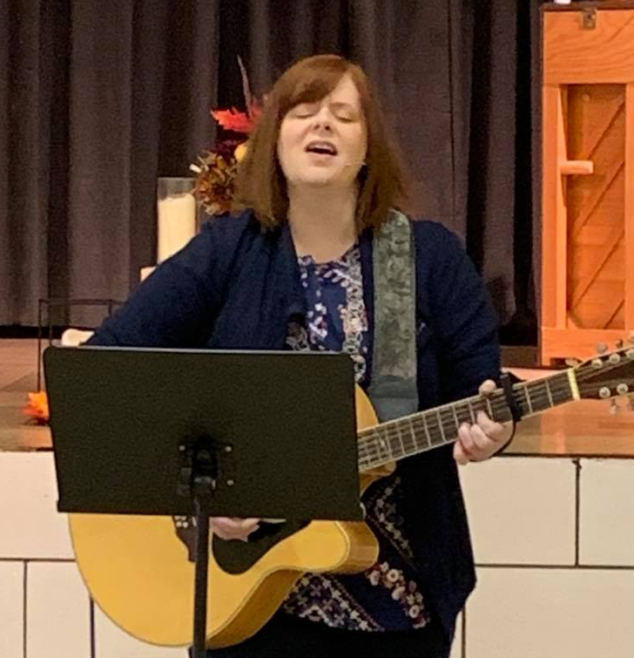
Our Heart for Homes Web-a-thon Was Tremendous!

Although this was an odd sort of year and fundraising efforts had to get creative, giving has increased by 20%! Our Heart for Homes Web-a-thon was birthed and delivered by our beautiful and talented friends Sarah Horning and Melissa Sylvis. We had a wonderful time doing it too! Melissa Sylvis graced us with her anointed worship, Laura and Greg Martel drove three hours to share testimony and volunteer for the workday, and many other testimonies were shared that day and preceding the event. Please visit this link to watch the web-a-thon and hear testimonies of what God is doing in the lives of others through Joel 2 Missions. You can also follow this link to take our virtual tour. Pastor Ken Huhn, board member and friend, had this to say about Joel 2 Missions; and more testimonies of lives impacted through J2M can be found here.

God Showed Up in Amazing Ways at the Connect to Healing Workshop at Christian Assembly of God in Bentleyville!
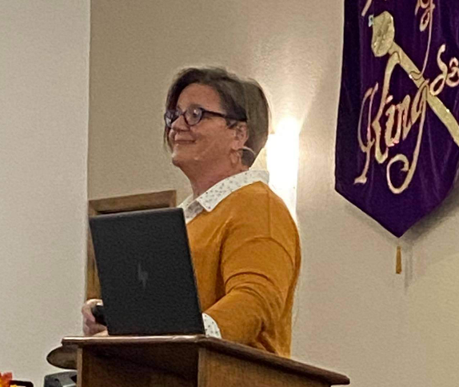
Pastor Paula had the honor of teaming up with Pastor Jason Jablonski for a one-day workshop on healing and deliverance. Pastor Jason taught on healing and Pastor Paula followed with truths about deliverance, dispelling myths and teaching the biblical basis for it. Holy Spirit came and signs and wonders followed the teaching of the Word as many were healed and delivered from past hurts and traumas as well as physical infirmities! Hallelujah! It was a glorious day in the Lord!

J2M Family Thanksgiving

What an awesome time we had in the Lord! Jesus has been blessing us so much in our Friday evening services and this dinner was no different! We had a wonderful time fellowshipping over food and then moved into an anointed time of worship, prayer, healing, and deliverance! There just are not words for how He has been dwelling here! So precious and special and we are humbled by the favor He has shown us! Please join us any Friday you are able at 6:30 pm at 234 Arensburg Road, East Millsboro, PA 15433.

Annual Appreciation Dinner: RESCHEDULED for Friday, January 8, 2021 at 6:30 PM

J2M would love to celebrate you and your dedication to the Lord through Joel 2 Missions! This event is for all partners, donors, sponsors, volunteers, staff, and their families! Please come join us as we fellowship, eat good food from Penncraft Market Catering, and hear the Word of the Lord for J2M for the year 2021. More details to be announced soon. Invitations did go out the first week of November but have the original date on them. PLEASE like our FB page for the most up-to-date information in real time. If you would like to attend but are not sure if we have your mailing address, please email it to us at joel2missions@gmail.com.

ONGOING EVENTS:

The Gathering at J2M

Please join us Friday evenings at 6:30 pm at 234 Arensburg Road, East Millsboro, PA 15433. The Lord has been showing up in such wonderful ways at these meetings. We do not feel led to livestream these meetings, but all are welcome to join us in person. The Gathering is a place where people can come together and just seek His face. Worship is the focus and there is an open mic for members of the Body to share what the Lord is showing them either through the Scriptures or revelatory gifts. If you would like more information, please email us at joel2missions@gmail.com.

Going Deeper with Joel 2 Missions (March 2020- Now)

We had been seeking the Lord about how to best execute discipleship classes. During the beginning of the shelter-in-place order, He made it clear that we were to do these teachings online. Each Tuesday at 7pm on FB Live, we teach on various subjects designed to help believers walk out the Word in their daily lives. Join us each Tuesday, or on replay, at www.facebook.com/paula.millsaps.

Regional Oneness Apostolic Roundtable- ROAR 2020 (June 2020- Now)

Born out of this time of deep intercession, reset, and refocusing, the Regional Oneness Apostolic Roundtable (ROAR 2020) is a group of Five-Fold Ministry Gifts gathered together from three states currently. The purpose is to provide a place for all parts of the Body of Christ to come together, hear from the Lord His plans and purposes for this region, and then seeking God together for the strategies for how to implement these plans in the earth. The response has been tremendous, and the Lord is already moving and uniting through this group. If you are interested in more information about ROAR, please email us at joel2missions@gmail.com.

ANGA Regional Connect Meeting (Coming SOON!!!)

Pastor Ken Huhn and Paula Millsaps are working on a returning schedule for this quarterly meeting. These meetings are life-giving and important to the Body so it will be very soon that we will begin meeting again. If you are interested in more information about this gathering, please email us at joel2missions@gmail.com.

IMPORTANT UPDATE: We are on hold waiting for the engineer to complete the blueprints for the sprinkler system due to health issues he has been facing. Please keep him, Mike Prinkey, and his family in prayer. ALSO… Please, do not lose hope and do not be discouraged. WE WILL SEE THIS HOMES FACILITY OPEN AND RECEIVING RESIDENTS SOON!!! God has promised it and it will come to pass! Please pray for finances to come in to support the construction and installation that will be needed to get the system in once the plans are completed! I know this is a hard time for everyone, but I encourage you to maintain your giving and even ask Papa what seed He wants you to sow in faith! You WILL reap a harvest that your storehouses cannot contain!

To Give, visit:
https://tithe.ly/give?c=1235990

Or send a Check or Money Order to:
Joel 2 Missions
P.O. Box 385
Donora, PA 15033

You are appreciated and loved dearly! We pray a hundredfold return on all that you do in the mighty name of Jesus! Please send us your prayer requests so we can agree with you for the will of God to be done in every area.

**Joel 2 Missions, Inc is a 501©3 non-profit organization. All donations are tax deductible. Giving statements will be sent out no later than January 31, 2021**
Joel 2 Missions is a member of the Apostolic Network of Global Awakening.

