Joel 2 Missions
Bringing in the Harvest
Joel 2:25-26
““So, I will restore to you the years that the swarming locust has eaten…. You shall eat in plenty and be satisfied and praise the name of the Lord your God.”

Dearest Beloveds of God,
I pray this finds you doing well, staying in Hope and Peace, and continuing in the good fight of faith! This is an amazing time to be alive! There are some who may disagree due to the situations, deaths, and losses currently associated with the COVID-19 pandemic and resulting precautions that are being taken in our society; but I believe it is in these darkest times when the Light of Christ shines brightest! One of my papas in the faith, Neil Blake, Jr., has been saying for years that he believed the coming years would be the best of times and the worst of times all happening at the same time. I have always believed this to be true and I can see it even more clearly now. Think about it for a minute. A pandemic shut down almost our entire world, there are people suffering and dying, and uncertainty in the world system abounds. As we heard from our President yesterday, we know we are in for at least thirty more days of social distancing protocols. While this sounds horrifying to some who are already feeling the impact of isolation from physical contact with others, it sounds like the perfect backdrop for the King of Glory to show Himself strong as never before!!! Why do I say that?
Because now, on a more massive scale than I have ever seen before, we have prayer calls, zoom meetings, and social media flooded with messages, worship, and prayer all over the world. Some have been blessed to organize feeding stations, some have led the charge in organizing prayer calls and meetings, many have met congregational needs through technology in ways we might have not considered before, and it is remarkable. Prodigals are returning to the Lord in repentance and reverence, online ministries are reporting higher salvation stats than ever, and miracles of healing and resurrection are happening every day. God is showing Himself strong and mighty in the face of the novel coronavirus. He cannot help but be Who He is! Hallelujah!
Did God cause this? Of course not! But He is using it and He will be glorified in it! I believe that we as His children have been invited into an awesome opportunity to partner with Him during this Divine Rest and Reset that we are being given. We must respond by taking time to look at what we have been investing our time, energy, and resources into. Time to evaluate what is truly important. Time to press into Him and really sit and be still and know that He is God. Let us understand and see this as a time to trust Him implicitly and to get to know another facet of His goodness. Let us also take this time to allow the Lord to highlight in our hearts any and everything that has exalted itself above the knowledge of Him and tear it down! A time to humble ourselves and give up all our controlling ways and simply be led by the Spirit. A time to rally together in prayer, recognizing that there is no distance between us by the Spirit of God, taking our eyes off man for the laying on of hands and receive straight from the Master. And, let us cherish this time to be knit together with our tribes, families, and neighbors no matter how far we are apart physically. This is a time for great creativity to flow, for masterpieces to be painted, books to be written, and new songs to be sung. A time to finish those home projects that we just never have enough time to complete. A time to sow our travel hours into soaking in His Presence. I believe this is also a time of strategic downloads, witty inventions, and a transfer of wealth from the wicked to the righteous. Really guys, tears flow as I see how the Bride is being unveiled at this time, for such a time as this!
Please hear me when I say, I understand the temptation to be pulled into feelings of isolation, frustration, and fear. But let me encourage you, He has already made a way for us even in these drastic circumstances! Let us make sure that we go to Him and receive His perspective of what is going on right now and shut out the other voices that are often so much easier to hear. Let us remember that we are already seated in heavenly places in Christ Jesus and we simply need to see this all from that place. Let us all ask the Lord to give us eyes to see this only the way He sees it and ears to hear only what He is saying about it and then flat out refuse to agree with anything else!
Identify the reality of your position in Him and then look again beloveds of God! Do you perceive it? Do you see the new things God is doing as He takes what the enemy meant for evil and uses it for good?
What an exciting time to be alive!

Please know that we are extremely thankful for all our partners, friends, family, and volunteers! Without you all we could not do the work that God has called us to around the world! This newsletter will cover our trip to Bolivia and a few other things we have been up to this year so far. As for upcoming events, most are on hold for now until the COVID-19 restrictions are changed. Please feel free to email us at joel2missions@gmail.com or call Susan at 910-599-0991 with prayer requests, praise reports, and testimonies! Also, we are still offering counseling and mentoring through various telecommunication streams. Please contact us if you need these services. Blessings and love to you all!

In His Service,

Paula Millsaps
Founding Director
Joel 2 Missions
(910) 599-0991

Bolivia, South America (January 19-February 3, 2020)

Oh, Bolivia! We fell in love y’all! This was a fast-paced, two-week-long mission trip that included twelve plane rides in fourteen days, hopping from city-to-city and sharing the love of Christ everywhere we went! It also included a couple weeks’ worth of severe digestive issues because we drank the water and ate the produce (we were told it would be fine…it was not…lol). Nonetheless God showed up in miraculous ways and opened doors we could have never opened on our own!

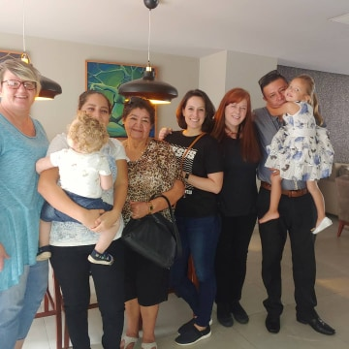
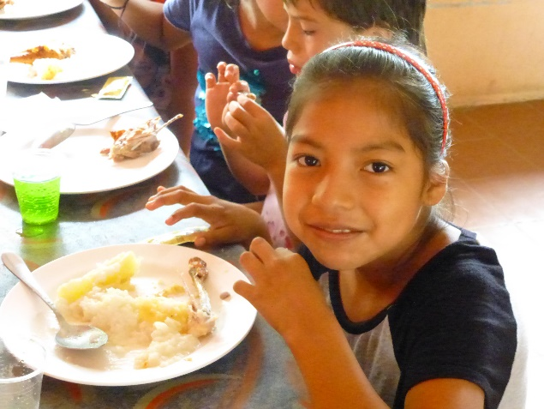
Santa Cruz, Bolivia was the first city we went to. There we met on our first day Carlos Pana, our driver. We fell in love with Carlos immediately and showed love and joy like he said he had never experienced. That first day we went to visit a recovery home called Noah’s Ark. The Ark has homes for men and women, but we only visited one of the women’s homes. God showed up!!! It was tremendous! They blessed us with a meal and coffee and then allowed all the women to come out to meet us. As they introduced themselves, I was moved to tears and just began to hug and love on them and pray over them all. There was not a dry eye in the place after the Lord swept through there! Everyone was ministered to! It was so glorious! It was here that a young lady was delivered from witchcraft and rebellion and had her lazy, weepy eye healed by the Lord. When we visited again before we left, we found that everyone there had experienced God in a new way that day. All the women could pinpoint a specific thing they were healed of…so precious! The next day we went to Jugar de Ninas (House for Girls). It is an orphanage of 43 girls from ages 3-18 who have all survived childhood sexual abuse of some kind. Oh, my heart! These sweet girls…I did not want to leave them! We were blessed to hang out with them, bless them with lunch and gifts, and minister to them and the workers there. When we left from there, we noticed Carlos was choked up. He told us he had never seen anyone love like we love and wanted whatever it was we had that made us love like this and have so much joy. Carlos gave his life to the Lord that day and we have remained in contact with him ever since. In fact, when we went back to Santa Cruz at the end of our trip, we got to spend time with his entire family!

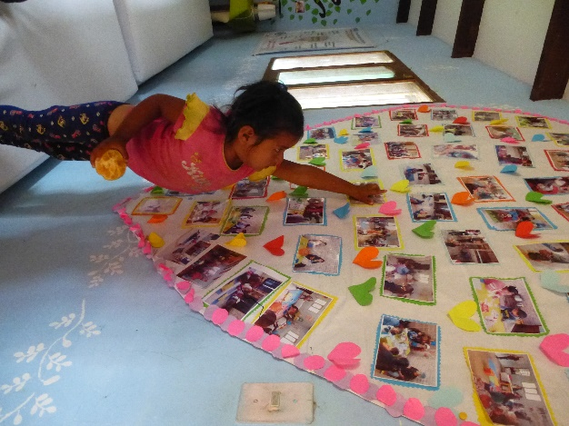
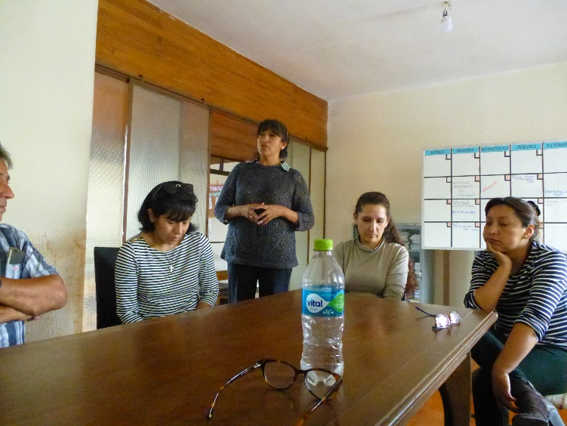
Cochabamba, Bolivia was our second city to visit. It was such a beautiful place and had amazing plazas and parks where families spent time together. The weather there was a perfect 75 degrees with no humidity. We loved it! While we were in Cochabamba, we visited an organization called FUBE. They work with children coming out of abuse and try to help rehabilitate the family units as well. We have been invited back to do inner healing and deliverance training for their staff and volunteers. Also, in speaking with them, we found out that Bolivia has no national sex offender registry and that because of this they often have harder times prosecuting offenders because they cannot prove they have offended before (this is also because once an offender serves their time their records are expunged and it is as though they never offended). These are both issues that are cause for great concern and if they were fixed could help many children get freedom from abuse. As the Lord would have it, we were able to meet with someone in Cochabamba that works with government registries and is willing to help us get the National Data Base and Registry started and an evangelist friend that one of our hosts “just happened to run into” was able to connect us with two pastors in La Paz (our next city) that could connect us to government to work on the other issue. This is how the hole trip went…just one open door after another. While in Cochabamba, we also visited Papa Hugo in the hospital. We were asked to go there and pray with him, and he ended up blessing us so tremendously that we were undone! Father asked me to bless his feet and prepare them for glory (Papa Hugo was 93 at the time and had lost all mobility in the natural but his spirit still soared with the angels!) I was honored to pray over his feet and anoint them as the Lord requested. Papa Hugo went on to be with the Lord just one month later.

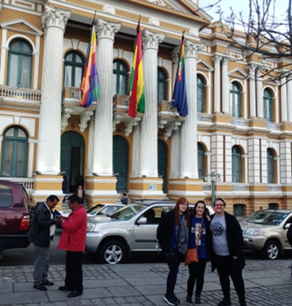
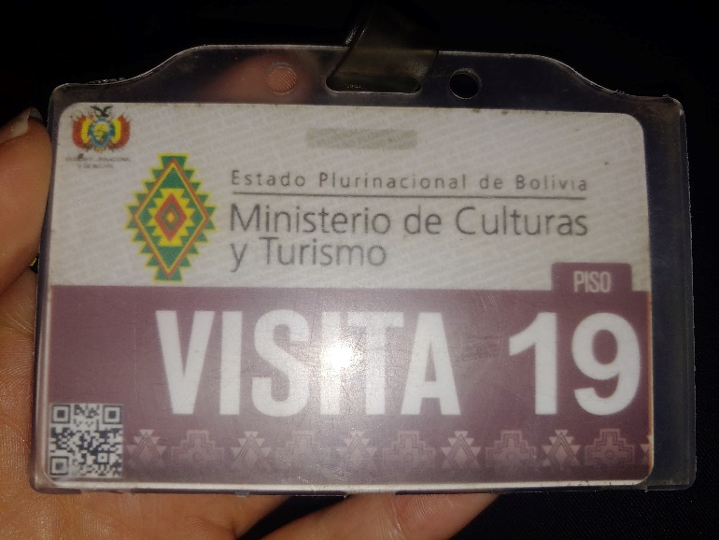
La Paz, Bolivia was next. It is the center of government and a very packed, bustling city. They are draped across mountain ranges that reach elevations of 19,000 feet. The city itself is 14,000 ft above sea level and is home to Lake Titicaca and the gate of the gods. We were blessed to meet with our new evangelist friend’s connections, Angel and Fernando, and they were just lovely! When we met for breakfast and told them what the vision is that God has given us for Bolivia, they immediately got on the phone and began to call their connection with the government. Before breakfast ended, we had a meeting scheduled with Nelson, the political aide to the Minister of Culture and Tourism, Marta. As we met with him, the Spirit of the Lord came, and I began to prophesy to Nelson. Tears flowed as he announced we would not have to meet for a possible appointment with Marta later that evening, but he was taking us to her immediately. The same thing happened with Marta. The Lord began to speak to her and told her things none of us could know. The next day they began to come to pass. We now have an open invitation to the country of Bolivia and are pleased to say that when we go back Marta wants us to meet with her, the new president, and the woman who is over the country’s widow and orphan programs. We have also been invited to preach in multiple churches and are already working on getting a Crusade planned with a member of government and a group of 200 pastors. Wow!

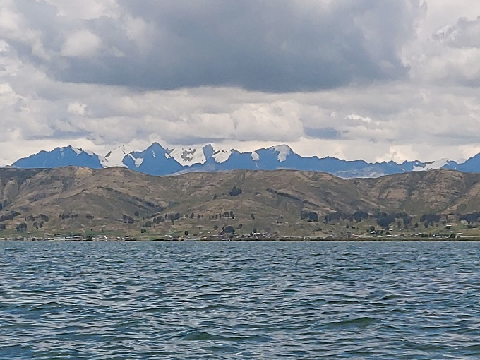
While in La Paz we were also blessed of the Lord to be sent on assignment to pray over Lake Titicaca. For centuries people there have reported seeing visions of ghosts and aliens coming out of the lake. People in that land are still to this day doing sacrifices, both human and animal, into the lake. In fact, one of the rooms we got to pray in at the palace was built for the purpose of sacrifice as the dictator that was just deposed was a professed Satanist. Blessing this lake was one of the most important assignments we had, and it was an honor to be trusted of the Lord to do this.

We are so looking forward to going back!!!

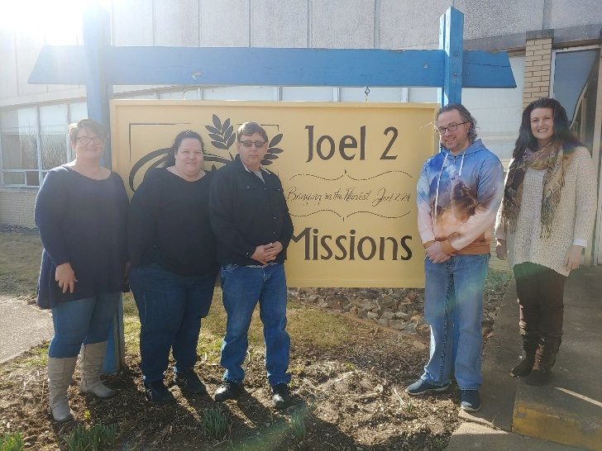
Volunteer Training (February 8-9 and February 29-March 1, 2020)

Our fourth volunteer training saw five more people trained in inner healing, deliverance, crisis management, and PTSD ministry. It was an excellent class and we are looking forward to being able to do the practical parts when these social distancing restrictions are ceased. Blessings to all who came out for this two-weekend boot camp! Future dates will be announced as soon as we know better what is happening with everything.
ANGA Regional Connect Meeting (March 6. 2020)

Oh, my what an amazing time in the Lord we had at this connect group meeting! We had 22 come out and enjoy dinner, fellowship, and ministry time. Most of us were Global people but Pastor Frank Menhart came and brought some from his church as well. The Spirit of the Lord was there as people received prophetic words, healing, deliverance, and much more from the Lord. Interestingly, Pastor Frank wept as we shared the testimony of Bolivia. He had been in Bolivia when the dictator that was recently deposed first took office. He shared how he had cautioned the Bolivian people against revolt and encouraged them to win their country back through fasting and prayer. He had not heard yet that that is exactly what happened—this dictator was deposed through prayer and fasting and peacefully!!! Glory to God! We are hoping to have Pastor Frank go with us when we return for the Crusades.

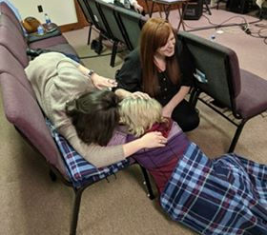
Weekend of Worship with Jubilee Christian Center (March 14-15, 2020)

What an amazing time we had at Pastor Terry Smith’s church in Clearfield, PA! Preached a firey message Saturday evening and prayed and prophesied over all who were there. Then Sunday I was blessed to share about Joel 2 Missions and the work we are called to do. It was a wonderful time in the Lord that produced great fruit for the Kingdom! Once the social distancing orders are lifted, we will be welcoming groups from this church for training and to bring donations.

We are so excited about what God has been and is currently doing! It is our belief that we should be using this time to rest and get ready for the great harvest of souls that will come in through this pandemic! Our job is to continue ministering to the Lord, help where and when we can, and continue in the work we have been called to. Although all we are doing now is online, we are still with you in prayer and are marching toward the future with sword in one hand and building tools in the other!

Please join us Friday evenings at 6:30 pm Live on my personal FB page at www.facebook.com/paula.millsaps for Healing Springs Gathering and Tuesdays at 7pm same place for Going Deeper with J2M. These Going Deeper meetings are teachings about various biblical principles that many ask questions about. Please feel free to email your questions and/or topics of interest that you would like to hear teaching about. We ARE taking requests! Please message me on FB or email us at joel2missions@gmail.com.

IMPORTANT UPDATE: We are on hold waiting for the engineer to complete the blueprints for the sprinkler system due to the coronavirus outbreak. Please, do not lose hope and do not be discouraged. WE WILL SEE THIS HOMES FACILITY OPEN AND RECEIVING RESIDENTS SOON!!! God has promised it and it will come to pass! Please pray for finances to come in to support the construction and installation that will be needed to get the system in once the plans are completed! I know this is a hard time for everyone, but I encourage you to maintain your giving and even ask Papa what seed He wants you to sow in faith! You WILL reap a harvest that your storehouses cannot contain!

Thank you so much to all of you who have supported and continue to support Joel 2 Missions as we storm the gates of Hell in Jesus’s name!

Please consider us when you are choosing where to sow your end of year giving. On top of the needed renovations, we still need 22 monthly sponsors at $150/month to take in the first 25 residents. Our goal is to be ready for them when this hurdle is jumped!

To Give, visit:

https://tithe.ly/give?c=1235990

Or send a Check or Money Order to:
Joel 2 Missions
P.O. Box 385
Donora, PA 15033

You can also call Susan at (910) 599-0991 and request permission forms to be set up for recurring monthly donations through our Merchant Services Account through PNC Bank.

You are appreciated and loved dearly! We pray a hundredfold return on all that you do in the mighty name of Jesus! Please let us know if you have any prayer requests by emailing them to us at joel2missions@gmail.com.

**Joel 2 Missions, Inc is a 501©3 non-profit organization. All donations are tax deductible. Giving statements will be sent out no later than January 31, 2020**

Joel 2 Missions is a member of the Apostolic Network of Global Awakening.

